Building and Construction

Carry out excavation



Learner Guide

Table of Contents

Carry out excavation 3
Compliance documentation 4
Safety requirements 5
Risks and hazards 7
Personal Protective Equipment (PPE) 11
Planning Excavation Work 12
Emergency procedures 13
Signage requirements 13
Securing the work area 14
Selecting plant, tools and equipment 15
Environmental protection requirements 17
Confirming excavation location 18
Using hand tools to excavate 21
Following organisational and site requirements when using tools 21
Making the area safe 22
Excavation Methods 23
Cleaning out the excavation 28
Checking the completed excavation work 29
Digging a Post Hole 29
Digging a Trench 32
Trench collapse prevention 39
Project quality requirements 57
Site Cleanliness 58
Glossary 61

Carry out excavation

Manual work
Manual excavation methods are usually used for small, shallow excavations (for example, less than 1.5 metres deep) in soft soils.
Potential hazards | Examples of control measures
- ground collapse | - the use of benching or the installation of ground support (for example, shoring)
- water inrush | - pumps or other dewatering systems to remove water and prevent build-up
- falls | - ramps, steps or other appropriate access into the excavation
- hazardous manual tasks | - rotating digging tasks between workers
- airborne contaminants | - mechanical ventilation to remove airborne contaminants
- buried contaminants (e.g. asbestos). | - training to identify buried contaminants and what action to take

When working in close proximity, workers should be kept sufficiently far apart to prevent injury from the use of picks or other hand tools. This applies particularly to work in trenches and small excavations.

Trenches and Excavations
When a construction project will involve digging trenches and excavation work, a builder should take particular note of the unique hazards that could arise, and the possible control measures to be implemented in an effort to eliminate or control such hazards.
Potential hazards that could arise include:
- Water pipes and electricity cables could lie in the area to be dug up
- Workers could fall when climbing in and out of a trench
- The trench could collapse on a worker
No soil or rock can be relied on to support its own weight, therefore the sides of any excavation are likely to collapse at any time. A cubic metre of soil (about 80 shovels full) weighs at least 1.4 tonnes.
Possible control measures may include any or all of the following:
- Check with the appropriate authority for the location of underground services (ie. gas, water, communications, electricity) before you dig.
- Provide and secure a suitable barrier or guardrails around any excavation.
- If workers are required to be in a trench 1.5 metres deep or more, the sides of the trench must be battered at an angle of 45 degrees or shored up with a trench support system. In some cases, trenches shallower than 1.5 metres in unstable ground should be battered. If you need advice, call your nearest WorkCover Construction Safety Inspector.
- Trenches can be open graves, so owner builders should provide suitable ladders for entry and exit from trenches. If the right precautions are not taken, the sides of the trench can collapse and anyone working in it can be buried alive. Don't let this happen on your owner builder site.
Some special safety considerations for builders are asking themselves whether all trenches on site have:
- a handrail or suitable barrier around the edge?
- 45 degree sloping sides or stepped sides - if not, are they shored up?
- any access ladders?

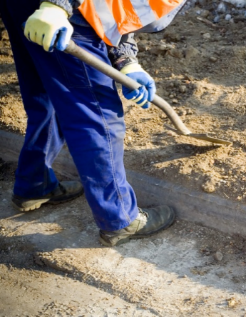

Compliance documentation
Documentation is essential to all aspects of every worksite. From environmental plans through to extraction plans, documentation exists that outlines what to do, when to do it and how it is to be done.
Compliance documentation is the name given to the documents that require you to undertake tasks in a particular way or to meet a given standard. Every civil construction worksite will have site-specific requirements, which will be outlined during your initial induction.
Some of this documentation can include:
Legislative, organisational and site requirements and procedures including:
- Employment and workplace relations legislation;
- Equal Employment Opportunity and Disability Discrimination legislation;
- Manufacturer's guidelines and specifications;
- Australian standards.
During your site induction you will be told how to access the documentation relevant to your site and duties.
When conducting manual excavations the compliance documentation you will most be using will be the specifications for the excavation, work instructions and the safety information.
Make sure you understand what these documents are asking you to do and if need be, check with your supervisor before starting work.
Follow all instructions given by these documents at all times – they are designed to keep you safe.

Safety requirements
Every work site must meet safety requirement for the state or territory where the site is located. Safety requirements are also outlined by organisational policies and procedures.
Some safety requirements are site specific. They may relate to factors specific to the work site such as weather, ground and environmental conditions. You will be told about these before you start.

Safe work practices
Safe work practices are methods that must be implemented to make sure a job is carried out as safely as possible.
Safe work practices include:
- Day to day observation of OHS policies and procedures;
- Correct use of tools and equipment;
- Materials handling techniques;
- Emergency procedures;
- Risk assessment;
- Use of basic fire-fighting equipment.
Safe work practices should be referred to, and documented, when completing Safe Work Method Statements as a guideline for how to carry out a task safely.

Safe Work Method Statements (SWMS)/Job Safety Analysis (JSA)
A Safe Work Method Statement (SWMS) or Job Safety Analysis (JSA) details how a job needs to be carried out including how specific hazards and risks, related to the task, will be managed and is developed by the employer for their employees.
They fulfil a number of objectives:
- They outline a safe method of work for a specific job (Safe Operating Procedures).
- They provide an induction document that workers must read and understand before starting the job.
- They assist in meeting legal responsibilities for the risk management process, hazard identification, risk assessment and risk control.
- They assist in effectively coordinating the work, the materials required, the time required and the people involved to achieve a safe and efficient outcome.
- They are a quality assurance tool.
A SWMS or JSA are used to organise your work priorities. Make sure you carry out the task in the correct order listed on the SWMS/JSA.

Confirming work instructions
If you are unsure of any instructions you have been given, you need to clarify them with your supervisor.

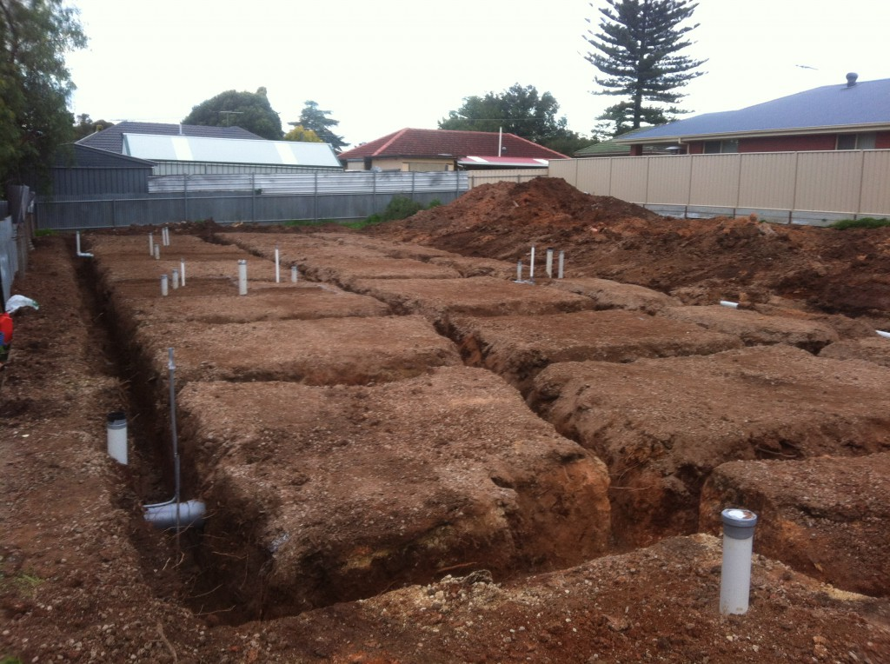

Risks and hazards

A RISK is the chance of a hazard hurting you or somebody else or causing some damage.
A HAZARD is the thing or situation that causes injury, harm or damage.
If you can remove or at least control a HAZARD you can reduce the RISK involved.
This is known as RISK MANAGEMENT.
Risk management is made up of the following stages:
Step 1 – Hazard Identification
Check the work area for any environmental or physical hazards that may exist. Remember to look above eye level and also to consider the ground surface. Hazards may also be caused by the way a task is carried out so be on the lookout for unsafe work practices.
Step 2 – Risk Assessment
Risk assessment is used to determine how serious a hazard is based on how likely it is to happen and the consequences if it does happen. The risk level of each identified hazard should be worked out.
Step 3 – Consultation and Reporting
Talk to other personnel about the hazard to figure out the best way of dealing with it. Also check for existing documentation to address the hazard.
Step 4 – Hazard Control
Once you have identified an appropriate response to the hazard you need to take the appropriate action to eliminate or minimise the hazard in accordance with site procedures.
Environmental practices need to be considered to ensure the organisation’s environmental plans are followed, and controls put in place if needed. Knowing the correct environmental practices and procedures for your organisation or site is essential. Environmentally sound work practices must be followed at all times.
Step 5 – Review
Once a hazard control measure has been implemented to deal with the hazard you need to review how effective it is and whether or not the level of risk has been reduced enough.
All hazards and control measures need to be reported in accordance with site and organisational procedures.

Identifying hazards
Some examples of excavation specific hazards include:
- underground essential services - including gas, water, sewerage, telecommunications, electricity, chemicals, and fuel or refrigerant in pipes or lines - information about the location of these and other underground services, such as drainage pipes and soak wells, and storage tanks, in and adjacent to the workplace, must be established before directing or allowing excavation work to commence
- the fall or dislodgement of earth or rock
- falls and falling objects
- inappropriate placement of excavated materials, plant or other loads
- the instability of any adjoining structure caused by the excavation
- any previous disturbance of the ground including previous excavation
- the instability of the excavation due to persons or plant working adjacent to the excavation
- the presence of or possible inrush of water or other liquid
- hazardous manual tasks
- hazardous chemicals (for example, these may be present in the soil where excavation work is to be carried out)
- hazardous atmosphere in an excavation (for example, using M.E.K. solvent for PVC pipes in poorly vented trenches)
- vibration
- overhead essential services (powerlines) and ground mounted essential services (transformers, gas and water meters).

Assessing the risks
When assessing the risks associated with excavation work you should consider things such as:
- local site conditions, including access, ground slope, adjacent buildings and structures, water courses (including underground) and trees
- depth of the excavation
- soil properties, including variable soil types, stability, shear strength, cohesion, presence of ground water, effect of exposure to the elements
- fractures or faults in rocks, including joints, bedding planes, dip and strike directions and angles, clay seams
- any specialised plant or work methods required (for example, ground support)
- the method(s) of transport, haul routes and disposal
- what exposures might occur, such as to noise or UV rays
- the number of people involved
- the possibility of unauthorised access to the work area
- local weather conditions, and
- the length of time that the excavation will be open.

It should then be possible to select the most suitable work methods and arrangement to eliminate or minimise risks, for example:
- excavating plant - when quantities are large, it may be productive to use different types of plant for the various materials to be excavated
- stockpiling arrangements - another site may need to be found for temporary stockpiling of materials
- material placement - the methods and plant used for excavating, transporting and compacting the material should be evaluated
- dewatering equipment, if required, and the system to be used, and
- transport of the excavated material - the type of plant used, the length of haul, the nature of the haul route, and the conditions of tipping and/or spreading are factors to consider.

Controlling the risks
The hierarchy of risk control
The ways of controlling risks are ranked from the highest level of protection and reliability to the lowest. This ranking is known as the hierarchy of risk control. You must always aim to eliminate a hazard, which is the most effective control. If this is not reasonably practicable, you must minimise the risk by:
- Substitution – for example, use an excavator with a rock breaker rather than manual method
- Isolation – for example, use concrete barriers to separate pedestrians and powered mobile plant to reduce the risk of collision
- Engineering – for example benching, battering or shoring the sides of the excavation to reduce the risk of ground collapse.
If risk remains, it must be minimised by implementing administrative controls, so far as is reasonably practicable, for example install warning signs near the excavation. Any remaining risk must be minimised with suitable personal protective equipment, such as providing workers with hard hats, hearing protectors and high visibility vests.
Administrative control measures and personal protective equipment rely on human behaviour and supervision, and used on their own, tend to be least effective in minimising risks.

Training, information, instruction and supervision
A person conducting a business or undertaking must provide any information, instruction training or supervision necessary to protect all persons from risks to their health and safety arising from work carried out.
A person conducting a business or undertaking must not direct or allow a worker to carry out construction work unless the worker has successfully completed general construction induction training.

Training specific to the excavation work and to the site should also be provided to workers, including:
- the nature of the hazards and risks
- how the work is to be carried out safely, including the contents of the SWMS
- information about underground and overhead essential services
- site emergency plans.
A competent person should supervise the excavation work. Workers in a supervisory role (for example, leading hand or foreman) should be experienced in excavation work and authorised to ensure the work is carried out in accordance with SWMS.

Reviewing risk control measures
All control measures that have been implemented, for example ground support systems and fall prevention devices, should be reviewed regularly to make sure that they remain effective.
There are certain situations where you must review your control measures under the WHS Regulations and, if necessary, revise them. A review is required:
- when the control measure is not effective in controlling the risk
- before a change at the workplace that is likely to give rise to a new or different health and safety risk that the control measure may not effectively control
- if a new hazard or risk is identified
- if the results of consultation indicate that a review is necessary, or
- if a health and safety representative requests a review.

Common review methods include workplace inspection, consultation, testing and analysing records and data. When reviewing control measures, SWMS and the WHS Management Plan must also be reviewed and revised where necessary.

Personal Protective Equipment (PPE)
Personal Protective Equipment (PPE) is worn on the body to protect it from injury. It includes:
- Hard hats;
- Hearing protection;
- Eye protection;
- Safety boots;
- Respiratory masks;
- Other prescribed clothing and equipment related to tasks.
Always use PPE in accordance with required procedures. Take care of your Personal Protective Equipment and make sure you keep it clean and free from damage.
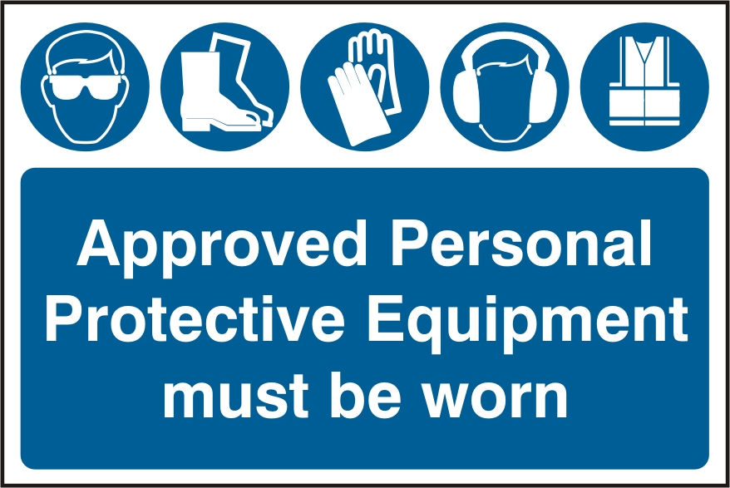
If you are performing work tasks in a variety of different work areas you may have to choose appropriate PPE for each context. Initiative and adaptability is important when dealing with changing work conditions.
Some PPE may be mandatory on particular worksites.
Planning Excavation Work
Excavation work should be carefully planned before work starts to ensure it can be carried out safely. Planning involves identifying hazards, assessing risks and determining appropriate control measures in consultation with all relevant persons involved in the work, including the principal contractor, excavation contractor, designers and mobile plant operators. Structural or geotechnical engineers may also need to be consulted at this stage.
Consultation should include discussions on the:
- nature and/or condition of the ground and/or working environment
- nature of the work and other activities that may affect safety
- static and dynamic loads near the excavation
- interaction with other trades
- site access
- safe work method statements
- management of surrounding vehicular traffic and ground vibration
- type of equipment used for excavation work
- public safety
- provision of adequate amenities
- procedures to deal with emergencies.

Principal contractor
Where the value of construction work exceeds $250 000, the construction work is considered a construction project and a principal contractor must be identified. There can only be one principal contractor for a construction project and this will be either the person commissioning the construction work or a person conducting a business or undertaking that is appointed as the principal contractor by the person commissioning the construction work.
The principal contractor has a range of duties in relation to a construction project, including:
- preparing and reviewing a WHS management plan
- obtaining SWMS before any high risk construction work commences
- putting in place arrangements to manage the work environment, including falls, facilities, first aid, an emergency plan and traffic management
- installing signs showing the principal contactor’s name, contact details and location of any site office, and
- securing the construction workplace.
It is possible that the excavation contractor may be the principal contractor. This might occur, for example, where there is significant excavation work required and there is a clear separation between the excavation activity and any subsequent building work. In this case the excavation contractor, as the principal contractor, must comply with all the duties of a principal contractor.

Emergency procedures
Emergency procedures will vary depending upon the worksite. These procedures could include:
- Emergency shutdown of site or equipment.
- Evacuation.
- First aid.
- Response to fire.
During any emergency situation you need to stay calm, respond accordingly and follow all instructions given to you.
If necessary you may also need to report the situation to your supervisor, or emergency services (police, fire, ambulance – Dial 000).

Signage requirements
On worksites it is often necessary to control the movement of traffic around and through the site.
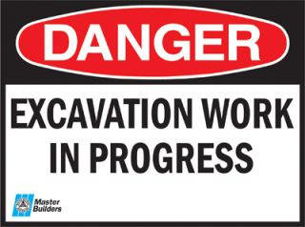
Signage is used to help control the flow of traffic in and around the work area to avoid exposing personnel and vehicles to hazards.
Sites that could require signage may include:
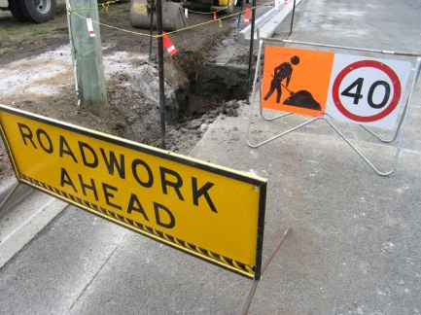
- Urban environments all require signage but the amount of signage will vary with the level of congestion or use. Low traffic or rural areas can have less signs than a major road.
- Off-road and un-trafficked areas will need isolation signage and restricted access signs.
- Hi-Use areas such as parking sites, pedestrian areas and buildings will require signage but this signage could vary depending on the location.
Any areas of open trenches should be signed and isolated from the public.
Signage requirements will differ depending where the site you are working is. Highway signage requirements are different to rural roads or footpaths. Refer to the traffic or vehicle management plans for guidance on signage requirements and positioning.
The majority of these signs are temporary and for the benefit of the motorist and pedestrians using the area while you are working there.
Common signs that are listed in the plans can include:
- Workmen ahead;
- Reduce speed;
- Traffic condition or change of condition signs;
- Indication of speed such as 60kms, 40kms;
- Speed zones are enforceable.

Securing the work area
A person conducting a business or undertaking who proposes to excavate a trench at least 1.5m deep, must ensure, so far as is reasonably practicable, that the work area is secured from unauthorised access (including inadvertent entry).

In securing the trench, you must consider:
- risks to health and safety arising from unauthorised access to the work area, and
- the likelihood of unauthorised access occurring.
This requirement aims to protect other workers on site who may be at risk by restricting access to the excavation area. It applies in addition to the duty that the person with management or control of the construction site has to ensure, so far as is reasonably practicable, that the site is secured from unauthorised access from members of the public, for example when the site is near schools, parks, shops or other public places.

Selecting plant, tools and equipment
Once you have identified the job requirements, you need to select the tools and equipment that will be used to excavate the area. Tools and equipment could include:
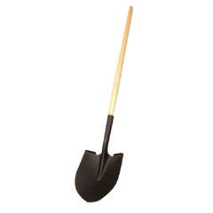 | 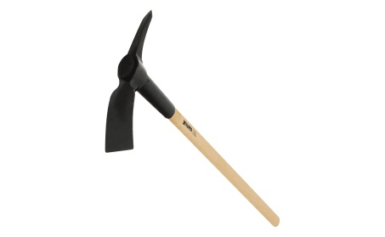 | 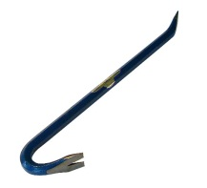 |  | 
Shovels | Picks | Crowbars |  | String Line
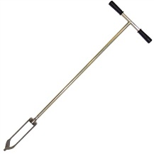 | 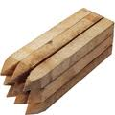 | 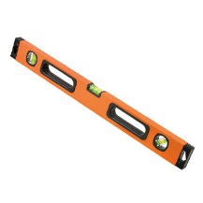 |  | 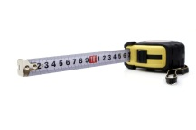
Hand Auger | Pegs | Levels |  | Tape Measures
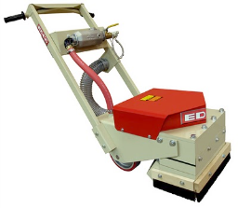 |  |  | 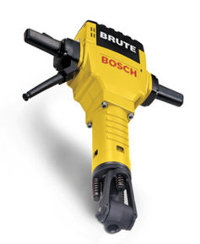
Scabblers  An attachment used to grind or remove small amounts of concrete at a time. |  |  | Jack Hammers

Once you have selected the tools and equipment that is best for the situation you are facing, it is essential to understand the capabilities and limitations of the equipment. The limitations will determine if the item is suitable.
Technical capabilities and characteristics of the item will be found in the operator’s manual.

Concreting equipment
Concrete equipment, tools and plant could be required once an area has been excavated. Often it is necessary to ensure you have the correct equipment, plant and tools to ensure the concreting can start as soon as you have finished excavating an area.
Typical concreting tools and equipment are shown below:
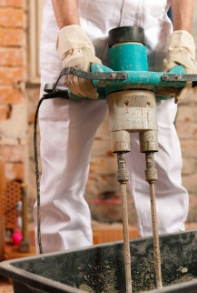 | 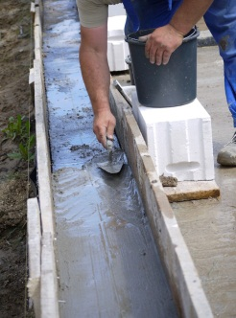 | 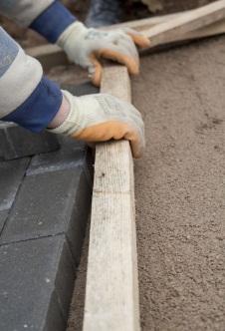
Small electric power concrete agitator | Formwork | Screed
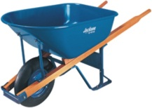 | 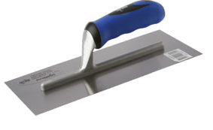 | 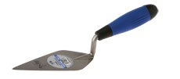
Barrows | Floats | Trowels
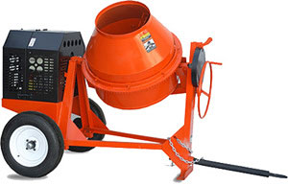 |  | 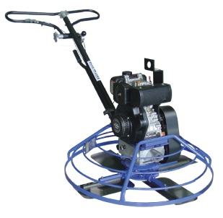
Mixer |  | Trowel Machine

You may also require other finishing tools to meet the job specifications.
Selection of the plant, tools and equipment needs to meet the needs of the task.

Equipment checks
Once you have selected the tools and equipment, you need to make sure each item is in safe working condition.
This involves:
- Checking the equipment for serviceability;
- Rectifying faults if possible;
- Reporting damage or faults that you cannot rectify.
The reporting of defective equipment must be done in accordance with your site requirements, which will be outlined during your worksite induction.

Environmental protection requirements
Environmental protection requirements control any aspect of the workplace activities from adversely affecting the environment as much as practicable.
When undertaking work activities, personnel should always aim to reduce environmental risk and waste.
To do this personnel are required to:
- Identify the environmental management plans, requirements and constraints.
- Confirm any aspect of the environmental management plan that may be unclear.
- Apply and comply with the project environmental protection requirements of all tasks undertaken in and around the workplace.
Environmental protection requirements include:
- Organisational/project environmental management plan;
- Waste/clean-up management;
- Water quality protection;
- Noise control;
- Dust management.

Environmental management plan
An environmental management plan outlines the steps and processes required to prevent or minimise harm to the environment through the use of machinery, equipment and potentially hazardous materials and substances.
Care should be taken to avoid negative impact on the environment throughout the duration of all work activities.

It is necessary for all personnel to have a good understanding of the environmental management processes that must be used in and around the site.
The Environmental Protection Authority (EPA) will investigate and fine sites that do not meet the state and federal environmental protection arrangements that are in place for all civil construction projects.

Waste and clean-up management
Waste and clean-up management may include taking steps to use environmentally friendly materials (including recycled materials). It also includes implementing methods of sorting waste into categories for recycling and correct disposal.
The plan will outline:
- Disposal of site waste materials and rubbish;
- Recycling waste materials;
- Re-use of waste materials.

Confirming excavation location
Before you start excavating in an area, you need to confirm the location of the excavation and the specifications that apply to the excavation.
You can confirm the location through:
- Worksite maps and coordinates;
- Site plans;
- GPS readings
- Tapes and other identifying markers;
- Service markers which will indicate locations.
Confirming the location of the excavation before digging will ensure you are excavating once only, not excavating, filling and excavating again.

Confirming specifications
Confirming the specifications before starting the excavations ensures you will be digging the excavation to the correct size, depth, shape and dimensions.
Confirmation before starting ensures you are able to complete the task once, correctly.



Checking for service markers
Once you have confirmed the location of the required excavation, it is then necessary to identify the service markers or taped areas.
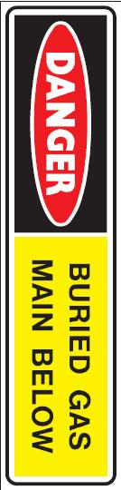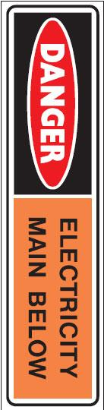
The taped areas should be obvious, with barrier boards, fenced areas, coloured tapes which indicate different services or requirements or other large, easily identifiable marks.
Marks could be smaller survey pegs.
Bollards or cones could be used for temporarily indicating taped areas.
Service markers are the plaques or tags that are placed on posts or other permanent structures to indicate where underground services are located.
Areas of disturbed ground could indicate recently placed services which have not yet had service markers attached.

Locating underground services
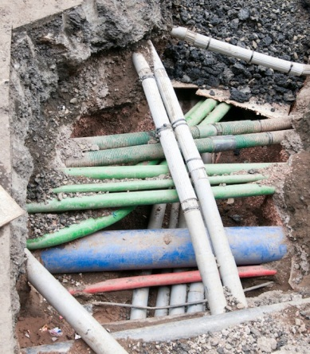
Once you have identified the service markers you will have an approximate location for the underground services.
Underground services could include:
- Power;
- Water;
- Gas;
- Telephone;
- Sewerage.
You will need to locate these services precisely to avoid damaging or interfering with them.
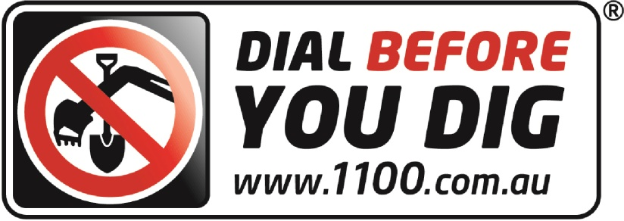
If you do cause damage or interference to the underground services, it is necessary to report the damage immediately in accordance with your worksite procedures and processes.
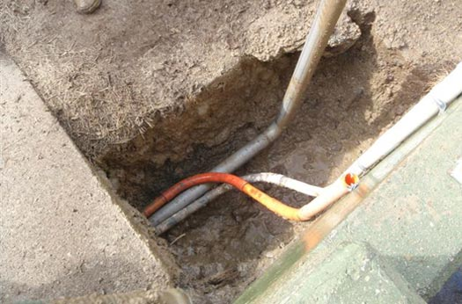
Confirming of the location of the services could be done by:
- Contacting the service owner;
- Checking council maps;
- Digging a small test excavation where the major excavations need to be completed.

Using hand tools to excavate
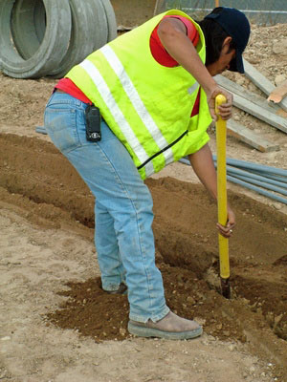
Commonly the excavations may include:
- Trenches;
- Post-holes;
- Pits;
- Holes.
When using hand tools to dig post-holes, small pits and trenches it is important that you use the tools safely and that you achieve the targets and dimensions required.
Safe use of the tools will ensure that the chances of you becoming injured while excavating is minimised.
Manual handling injuries commonly occur during excavation activities. When digging, ensure you are keeping your back as straight as possible and are placing the foot on the shovel fully to avoid your foot slipping (which may cause ankle or knee injuries).

Following organisational and site requirements when using tools
Knowing how to use tools safely is essential to keeping you and those around you from harm.
Read all documentation that applies to the tools and equipment you are using. Make sure you are familiar with the common problems associated with the equipment or tools and the management of these problems.
Speaking with team members or team leaders who have used the equipment before will help you identify any potential issues or problems.
If you are unsure of how to use a hand tool, it is important that you ask for training in using the hand tools before you start working with them.

Making the area safe
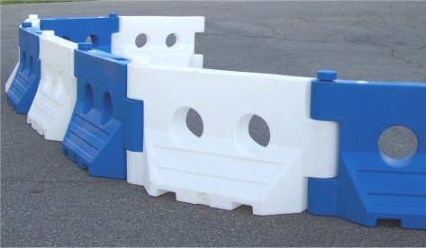
Barricades are used to isolate the excavated areas from people who are moving around or past the excavation.
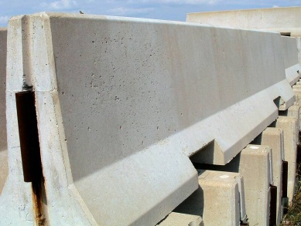
Areas where the work area has been levelled or is in the process of being levelled will often be barricaded. Barricades could include:
- Bollards;
- Tape;
- Mesh fencing;
- Paraweb fencing;
- Concrete barriers;
- Barrier boards.
The most appropriate type of barricades will be determined by the site requirements and the materials the site has access to.
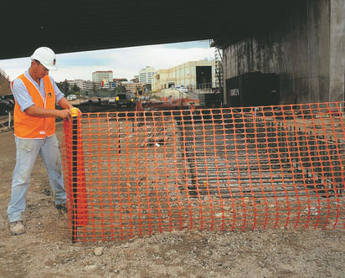
To place the barricades around the excavation, you will need to:
- Collect the barricades from the storage location.
- Erect the barricades in a manner that meets the specifications of the task, the site and of the barricade material manufacturer.
- Check the barricades are effective and completing the tasks correctly.
Each worksite should have specific safe work method statements for the erection of barricades. It is essential that you know and use these procedures.
Excavation Methods
The nature of the excavation work being undertaken will affect the selection of an excavation method and a safe system of work. Careful consideration should be given to health and safety issues when planning the work where the excavation involves anything other than shallow trenching and small quantities of material.

Trenching
A person conducting a business or undertaking who proposes to excavate a trench at least 1.5m deep, must minimise the risk to any person arising from the collapse of the trench by ensuring that all sides of the trench are adequately supported by one or more of the following:
(a) shoring by shielding or other comparable means
(b) benching
(c) battering.

A combination of these risk controls may be most effective depending on the work environment and characteristics of the excavated material. In streets or in built up areas, the excavation may have to be fully or partly sheeted to prevent partial or full collapse due to localised vehicle movement.
Where a worker enters a trench and there is a risk of engulfment, these risk controls should be implemented no matter how deep the trench.
A geotechnical engineer’s report may be required to provide information on the stability and safety of a trench excavation. The report should include details of the soil conditions, any shoring or trench support requirements, dewatering requirements and any longer term effects on stability and safety of the excavation. An engineer or other suitably competent person should design any support systems or be involved in the selection of other ground collapse risk controls, such as trench shields (see also Chapter 5 of this Code).
Shoring, benching and/or battering may not be required if written advice is received from a geotechnical engineer that all sides of the trench are safe from collapse. Any such advice must state the period of time to which it applies and may be subject to a condition that specified natural occurrences may create a risk of collapse.

Preparation and excavation
Bulldozers, scrapers, excavators and other types of earthmoving equipment are commonly used for either preparing work areas prior to trenching or for the trenching work itself

For some trench excavations, manual work, such as trimming by hand, will be required. Trimming can often be accomplished from outside the trench by shovelling or pushing the material with a long handled tool or shovel to the bottom of the excavation where it can be picked up by the excavation plant. Risks associated with falls and working with powered mobile plant must be controlled.

Tunnelling
The nature of tunnelling work is complex and highly specialised, requiring high levels of engineering expertise during the planning, investigation, design and construction stages.

There are also a range of construction techniques, ground conditions and health and safety considerations that may impact on ongoing operational and maintenance risks.

Design
Safe tunnel construction depends on adequate pre-construction engineering investigation of the ground and site and accurate interpretation of the information obtained. Designers should:
- obtain or be provided with all available relevant information
- be advised of any gaps in the information for planning and construction
- undertake or be involved in data acquisition for the site investigation program, and
- have on-site involvement during the engineering investigation.
The information obtained from the engineering investigation and the anticipated excavation methods should be considered in preparing a tunnel design. The design should include:
- details on the tunnel dimensions and allowable excavation tolerances
- temporary and final support and lining requirements for each location within the tunnel, and
- any other requirements for the finished tunnel.
The design should also include information on the excavation methods and ground conditions considered in the design, to allow the design to be reviewed if another excavation method is chosen or the ground conditions differ from that expected as the excavation proceeds.
The design also needs to take into account the construction methods that may be used to construct the tunnel so that a safe design for construction purposes is achieved.

Tunnelling hazards and risks
Common hazards and risks in tunnel construction generally relate to the confines of working underground and can include:
- tunnel stability – rock or earth falls and rock bursts
- changing ground conditions – strata and stress fluctuations
- limited space and access, with possible confined spaces involved
- air contamination or oxygen depletion
- fire or explosion
- the use of fixed and powered mobile plant and vehicles
- temporary electrical supplies and circuits, including loss of power for lighting and ventilation
- compressed air use and high pressure hydraulics
- large scale materials and equipment handling
- overhead seepage, ground and process water
- uneven and wet or other slippery surfaces
- falls of people or objects
- contaminated groundwater
- ground gas and water in-rush
- noise
- vibration
- heat and humidity, and
- hazardous substances.

Risk control measures can include:
- ground support, such as tunnelling shields
- appropriate fall protection, such as temporary work platforms
- plant and vehicular traffic management systems
- regular plant maintenance
- pumps or dewatering systems to remove ground water, and
- mechanical ventilation to control airborne contaminants and air temperature/humidity
- dust extraction
- plant fitted with water scrubbers
- plant fitted with catalytic converters.

Using ground support designed for the unique circumstances of the work is essential to control the risk of a collapse or tunnel support failure. Tunnelling is usually carried out using steel shields, however all excavation for tunnelling should be supported.

Shafts
Shafts are often constructed to provide access or ventilation to a tunnel. Comparatively shallow shafts can be sunk for investigating or constructing foundations, dewatering or providing openings to underground facilities.
Shafts vary greatly in design and construction technique, depending on their purpose and the local conditions, and may be vertical or inclined, lined or unlined, of various shapes, and excavated using various techniques.
Shaft sinking involves excavating a shaft from the top, with access and spoil removal from the top. Other construction methods include raise-boring, which is a method of constructing a shaft (or raise) where underground access has already been established. Raised bored shafts can be from the surface or from one horizon to another underground. The method can be remotely executed, not requiring people to enter the shaft.
Access to shaft openings should be controlled, firstly by using a secure cover that is lockable and accessible only by competent or authorised persons. A secondary means for controlling access to shaft openings is by using a suitable guard rail and toe-board with gate for access. The sides of the shaft should be supported by steel frames or sets of timber. In special cases, support can be provided by installing precast concrete or steel liners.
Shafts usually have special features so design and construction advice should be obtained from a competent person (for example, engineer) before excavation and installation. In some cases, special ventilation facilities may be required.
Common hazards and risks involved in shaft construction can include:
- shaft dimensions limiting work space, possibly including confined space work
- falls and falling objects, including fine material and water from the shaft wall
- hoisting equipment (for example, winch, ropes and hooks)
- hoisting and winching people, materials, spoil and plant
- water inflow/inrush and dewatering
- airborne contaminants and ventilation
- confined space
- manual tasks
- hazardous materials
- fire or explosion
- communications, and
- emergency egress.

Risk control measures can include:
- stabilising the ground at the head of the shaft
- lining the shaft continuously during its excavation
- providing appropriate fall protection, such as temporary work platforms
- providing and maintaining appropriate hoisting equipment
- installing dewatering systems
- installing mechanical ventilation to control airborne contaminants and air temperature/humidity
- guiding the working platforms and material
- avoiding overfilling material kibbles and cleaning kibbles before lifting
- closing shaft doors before tipping, and
- cleaning the spillage off doors, stage and any steelwork.

Cleaning out the excavation
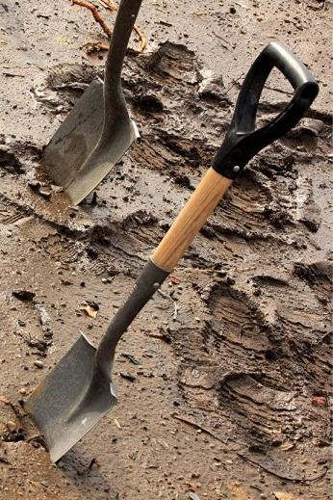
Loose materials will need to be removed from the excavation. Normally this is best achieved by using appropriate hand tools.
These hand tools could include:
- Trowels;
- Small shovels;
- Rakes.
When removing loose materials, it is important to ensure the materials are placed in an appropriate location. Generally, these materials are located close to the main excavation.
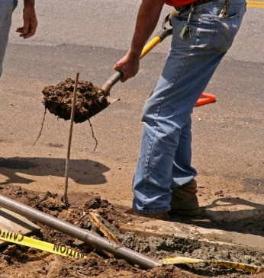
If the materials are to be used to fill the excavation once work activities have finished, ensure the materials are not contaminated with foreign substances.
Any materials that have been contaminated with foreign substances should be checked by the environmental officer onsite before being reused.
Contaminated materials will also need to be reported in accordance with the site environmental management policies and procedures. If you are unsure of how to do this, speak with a supervisor or the site environmental officer.

Checking the completed excavation work
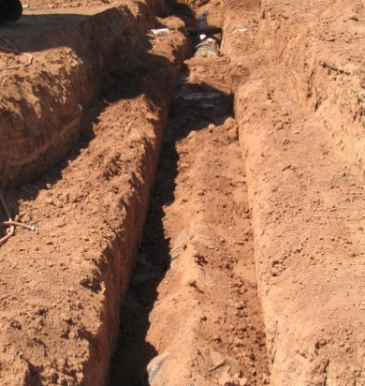
Once you have completed the excavation, it is necessary to double check that it meets the specifications or work instructions.
You do this by measuring the excavated area for size, depth and dimensions and ensuring the excavated area meets the specification.
If necessary you could have the area surveyed by the organisations survey team. If you are in doubt about the excavation, ask another person to double check what you have done.
Digging a Post Hole
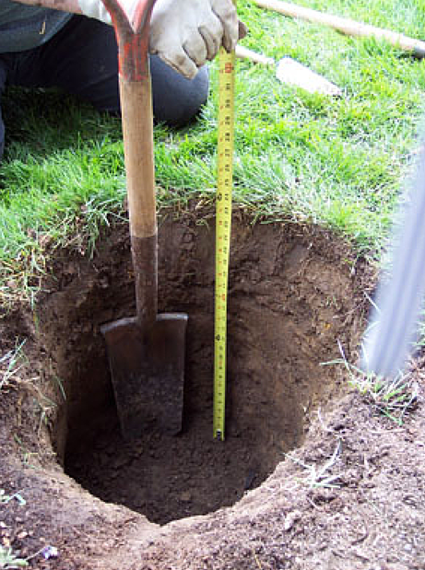
Whether it’s for a new mailbox or a fence, you need to get it right. It’s not just a matter of digging a hole. There are specific tools and techniques you’ll need to use to install a straight, stable and long-lasting post.
We’re going to assume you’ve laid out your post locations using string and stakes knocked into the ground. This is important not just so you install your posts in the right spot, but also because the stakes will form the start and centre point of your hole (not to mention finding any major obstacles like a large rock surface under the soil).
When it comes to depth, the rule of thumb for fence posts is a third (⅓) of the fence height = post depth. So for a 1.8m fence, you need to dig down 600mm. Opinions on the diameter of your post hole vary but generally speaking, the wider the hole, easier to ensure that the post is upright; however, the more concrete will be needed to secure it.

Tools of the trade
- Shovel
- Tile or digging shovel
- Post hole diggers
- Reciprocated saw
- Steel crowbar
- Post hole augur (under certain circumstances)
- Or a bobcat

Six steps to the perfect hole
- Start with a shovel and dig around the stake to centre the hole. This is your pilot hole. Tip: Throw the dirt onto a tarp to protect your lawn.
- A special digging shovel with a narrow blade and straight, sharp edge to slice through roots and turf will get your hole started more easily. Carve away at the sides of the hole. It’ll easily slice through small roots.
- Take your post hole diggers. Holding a handle in each hand, with the handles close together, thrust the blades into the dirt. If the soil resists, you might need to repeat that downward thrust a few times to cut into the soil and break it up. Make sure you’ve penetrated the soil a good few inches before you extract the dirt.
- You need to open up the handles to capture the soil in the jaws of your post hole diggers. Lift the diggers out of the hole and swing them off to the side of your hole, closing the handles to release the soil onto your tarp.
- Keep going in this way. If roots or other obstructions slow your progress, try rotating the blades so you’re thrusting into the dirt from a different angle. Start narrow and make the hole wider as you go deeper (this will help stabilise the post), although you’ll only be able to do that if the soil is holding its shape reasonably well. Moist soil will hold better than dry soil.
- Tamp or pack the bottom of the hole to compress any loose soil. You can add a little depth to put in some agg stones, or even a brick, to help water drain away. This stops the base of the pole sitting in water or soggy soil.

More powerful digging options

Post Hole Augur
Go slow. They have a fair bit of torque and if they ‘bite,’ it’s you that will start rotating! You can dislocate a shoulder. You really need some brawn to operate one of these, and their effectiveness can be limited in clay or rocky soil.
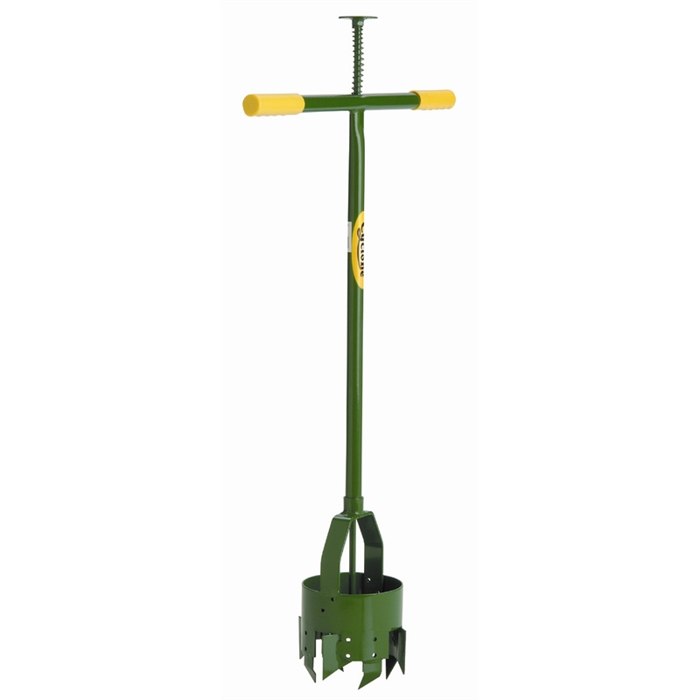

Tips and Troubleshooting
- Dial before you dig. Nothing worse than having to replace the neighbour’s pipes that were illegally run through your property once upon a time.
- Wet the soil if you encounter very hard or sandy, dry material you can’t extract with a reasonable effort. Allow the soil some time to soak up moisture.
- Use a steel crow bar for dislodging rocks. Knock them loose and lift them out with your post hole diggers.
- If you leave the site, cover the holes for safety and to prevent caving.
- Unless you’re bench-pressing 100, avoid those giant, heavy-gauge, post hole diggers. You’ll just get exhausted. You’re better off with a smaller, lightweight pair.
- Saw through large, tough roots with a long blade like (e.g. a reciprocating saw).

Digging a Trench

Trenching tools

Making sure that you've got the right tool for the job is essential in any workplace but in the irrigation industry it is especially important as turf and plants won't survive for long if they aren't regularly supplied with enough water. This is why when installing a new irrigation system, speed and efficiency are the key.
In this article we're going to take a closer look at the most common tools used to dig trenches and we'll investigate the pros and cons of each type.
Trenching tools are fast and efficient because they are designed to only remove the bare minimum of soil required to establish a trench to the necessary depth. They can be split into two groups: powered trenching machines or hand tools.

Powered trenching machines
There are a number of different companies that manufacture trenching machines but the most common machines are listed below.

Chain Trencher
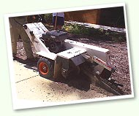
A chain trencher is a machine that drives a chain to dig trenches. Its action is similar to a chain saw and the chain moves around a blade to excavate the soil. They are used for large commercial irrigation projects where digging into hard soil is a problem. The width of the trench needs to be kept to a minimum where a deep trench is required. Cost to hire varies depending on size and is usually expensive.
Pros: | - Used for hard to reach areas.  - Used where a large job is required.  - Fast digging.  - Removes soil from excavation.  - Reduced labour costs.  - Reduced physical labour.
Cons: | - Expensive to hire and move around (truck required).  - Not suitable for small domestic irrigation jobs.

Excavators
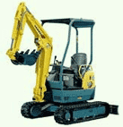
An excavator is a track driven machine, which operates by scooping the soil and depositing it beside the trench. They are used for large commercial irrigation jobs where large pipes will be laid or multiple pipes will be installed in the same trench. Cost to hire is based on an hourly rate and is hired as an owner/operator with a truck as transport.
Pros: | - Track machines are less likely to cause damage to landscapes as they minimise damage to the soil/turf.  - Long reach of boom arm.  - Able to dig large holes very quickly.
Cons: | - The transport of the machinery to site is expensive.

Disc or blade trencher
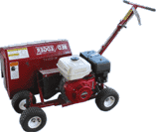
These are small motor driven machines designed specifically for digging small trenches usually 80mm x 200mm. They are inexpensive to purchase, are fast and make light work of digging. They are easy to transport in the back of a ute.
Pros: | - Cost effective.
Cons: | - Safety must be considered and operators should be trained in the trencher's correct use.  - Blades can wear out quickly and require replacement (depending on soil conditions).

Others: Skid steer machines
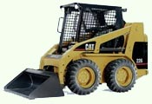
These are machines with buckets that are used to move soil and are useful for levelling and general earth works. Called bobcats in some places, skid steer machines are not generally used to dig trenches, as this may require adapting the machine for the purpose. They are hired by an hourly rate for the owner/operator and need a truck for transport.
Pros: | - Useful for levelling and returning soil from excavations. Can be used in small spaces.  - Fast with good results - high quality finish.  - The weight of the machine helps compact filled in trenches.
Cons: | - Expensive to hire and can cause damage to recently installed irrigation systems by running over sprinklers and pipes.

Hand tools
Powered trenching machines are often quite costly to buy (or even hire) and are usually only needed on very large jobs. So when digging trenches you are more likely to use one of the following hand tools. Each of these has safety requirements for use and in particular, safety boots should always be worn.

Trenching shovel
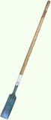
A trenching shovel makes light work of narrow trenches as it only removes soil wide enough for pipe work.
The square mouth of the shovel helps keep a flat bed for the pipe to lie in. The handle (made either of plastic or wood) should be light and strong and preferably long handled to ease the strain on the back.
Pros: | - Lightweight, narrow and purpose built for hand digging trenches.  - Inexpensive  - Available from most hardware stores.
Cons: | - Only suitable for digging trenches and small excavations.

Turf Cutter
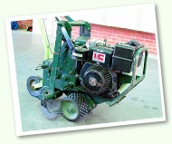
These are small motor driven machines that have a V shaped blade attachment for cutting into the turf. This allows for the removal for the turf sod whilst creating the trench at the same time. They are hand-operated machines.
Pros: | - Useful for returning the sod back into its original place resulting in quick site recovery.  - Inexpensive to operate.
Cons: | - Not suitable for deep trenches.  - Hand pushed and slow to operate.  - Cumbersome to use especially in tight spaces such as corners.

Spade
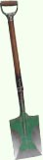
Spades can be used to cut trenches in existing lawn, as they have a sharp blade. They are inexpensive and available from most hardware stores.
Pros: | - A multi purpose-digging tool.  - Its sharp edge allows it to cut though the soil.  - Spades are readily available and inexpensive.
Cons: | - Not suitable for lifting soil.

Shovels
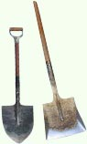There are generally two types of shovels used in industry: the wide mouth shovel and the pointed mouth shovel.
The wide mouth shovel is useful for picking up sand and other materials from hard surfaces and the pointed mouth shovel is used for excavation when large amounts of sand need to be removed.
Pros: | - Shovels are useful for lifting and moving small amounts of soil.  - Readily available.
Cons: | - Not a digging tool.

Pick axe
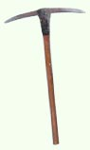
Pick axes are another useful tool to have around when you need to excavate trenches. They can be used to cut through existing roots or hard ground to create trenches.
Pros: | - Useful for penetrating hard ground and breaking it up so that the trench can then be prepared with a trenching shovel.
Cons: | - This is a single purpose tool.  - Heads may be prone to coming loose as the axes age.

Rake

Rakes are inexpensive and are often used to clear rocky or uneven ground prior to excavation
Rakes can be used to tidy up sites after trenches have been excavated and they are also used to refill trenches after pipes have been laid.
Pros: | - Inexpensive and a 'must have' piece of equipment for the clean up stage at the end of the irrigation installation job.
Cons: | - There are many types of rakes available and you must select the correct one for the job at hand.

Hand trowel
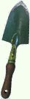
Hand trowels are useful tools for clearing trenches after the pipe is laid. They are also good for small excavations.
Pros: | - Inexpensive and handy for very small spaces.
Cons: | - Suitable only for very small excavations.

Mattock
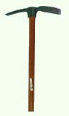
Mattocks are useful for cleaning out trenches in sand or breaking soil when digging is hard.
Pros: | - Inexpensive and handy for many jobs.
Cons: | - Heads may be prone to coming loose.

How to dig a trench safely
Step 1  After you have marked your trenches commence digging along the marked lines. | 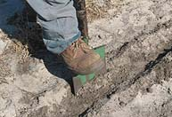
Step 2  Make sure you take into account any obstructions e.g. tree roots, pipes and services. Remove any rocks or obstructions that could damage pipework. If you encounter a tree root, you will need to dig through it. | 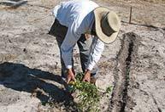
Step 3  Whenever you dig trenches, it is important to always place excavated soil on one side of the trench only. This will ensure minimal site disturbance and disruption while making it easier to join pipes and install them in a safe manner. | 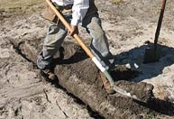
Step 4  Ensure that the depth of the trench is uniform and takes into account the height of the sprinklers and valve boxes. You might like to mark your trenching shovel with paint and drag it along the trench. This will allow you to see if the trench is uneven. | 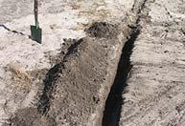

Trench collapse prevention
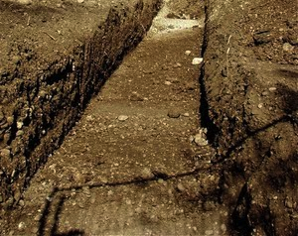
Preventing a trench from collapsing is important to ensure the safety of people and machinery working in or near the trench.
Any trench that is more than 1.5 metres deep needs shoring using materials that are appropriate for the site.
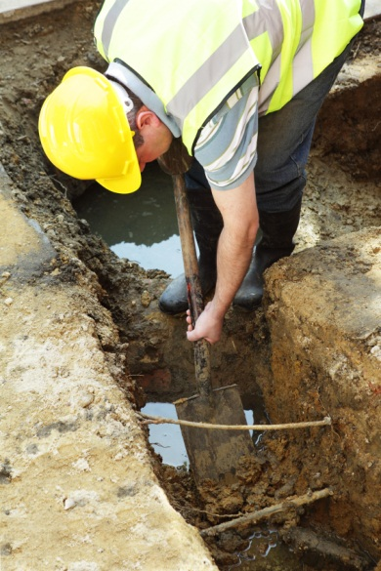
An assessment of the soils and materials you are working with will help to determine the most appropriate shoring or support techniques.
Soils or materials that are less stable will require more extensive shoring than materials such as clays which are relatively stable.
Benching and battering of the sides of the trench is commonly used to prevent trench collapses.
Benching is the creation of steps into the sides of the trench. By creating benches within the sides of the trench, you are able to minimise the risks of materials being knocked down into the trench.
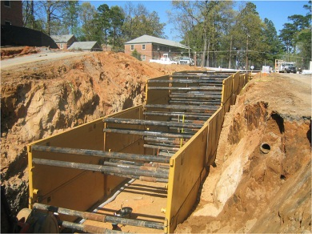
Batters refer to the sides of the trench or the sloping areas of the trench.
Trench shields are temporary walls that can be installed within a trench. These walls are prevented from moving in through a series of braces.
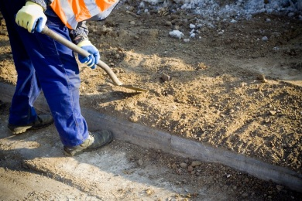
The trench collapse prevention system that is favoured by your site will be documented and made available to help you determine the safest method of shoring the trench.
If you are unsure of how to install the most appropriate trench collapse prevention system, speak with your supervisor or site safety officer. They will be able to discuss your options with you.
Ground collapse is one of the primary risks to be controlled in excavation work. Ground collapse can occur very quickly and without warning, giving a worker virtually no time to escape, especially if the collapse is extensive. A buried worker is likely to die from suffocation before help arrives (for example, either the head is buried, or the chest is so restricted by the weight of ground that the worker can no longer breathe).

Figure 2 shows a typical example of ground failure where material collapses onto a worker pinning them against the wall of a trench. Trench collapses of this nature can cause fatal injuries.

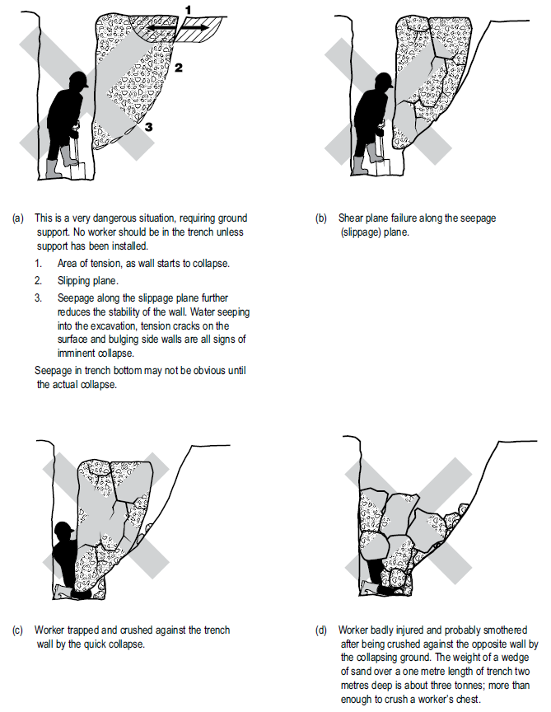

Figure 2: Trench collapse and associated ground forces

When planning the work and selecting appropriate excavation methods and risk controls, it is important to consider:
- the type and strength of the material to be excavated (for example, whether the ground is natural and self-supporting or has been previously backfilled)
- the moisture content of the soil
- if the ground is level or sloping
- if groundwater is present
- if there are any other nearby water courses, drains or run-off that might affect the stability of the excavated material
- the work area and any access or operational limitations
- the planned height of the excavated face
- if vehicular traffic and/or powered mobile plant will operate near the excavation
- if there will be other construction activity nearby that may cause vibration
- any other loads adjacent to the planned excavation (for example, buildings, tanks, retaining walls, trees), and
- any underground essential services.

The ground conditions will have a significant impact on the selection of an excavation method and risk controls.

Ground conditions
In their natural condition, soils have varying degrees of cohesive strength and frictional resistance. Examples of materials with virtually no cohesive strength are dry sand, saturated sand and gravels with minimum clay content. Ground encountered in excavations can generally be categorised as one of three main kinds:
- hard, compact soil
- soil liable to crack or crumble, or
- loose or running material.

Of these materials, hard compact soil is the type that can cause the most trouble because the face ‘looks good’ and this often leads to risks being taken. Loose or running material is often the safest, because the need for safety precautions is obvious from the start.

Soil liable to crack or crumble is doubtful, and should be given careful consideration before the treatment to be given is determined. Useful information can often be obtained by inquiring from local authorities.

Non-cohesive faces can be very hazardous. With just the right amount of moisture, they look, for a short time, safe and solid. However, very little loss of water by evaporation can make the soil crumble, as could an increase in the water content from rain or other causes.

The stability of any excavated face depends on the strength of the soil in the face being greater at all times than the stresses it is subjected to. The following situations all increase soil stresses in an excavated face and may lead to possible failure under adverse weather conditions, additional load or vibration:
- deep cuts and steep slopes, by removal of the natural side support of the excavated material
- loads on the ground surface near the top of the face, such as excavated material, digging equipment or other construction plant and material
- shock and vibration, which could be caused by pile-driving, blasting, passing loads or vibration producing plant
- water pressure from ground water flow, which fills cracks in the soil, increases horizontal stresses and the possibility of undermining, and
- saturation of soil, which increases the weight and in some cases the volume of the soil.

Soil strength may be reduced by the following:
- excess water pressure in sandy soil which may cause boils. It may saturate the soil and increase its plasticity
- dryness of the soil, which causes reduction of cohesion in sandy soil and soils high in organic content which then crumble readily
- prolonged stress, which may cause plastic deformity (squeezing or flowing), and
- prolonged inactivity at an excavation site. Where this occurs, an evaluation of the soil should be undertaken before work recommences.

There are three main types of ground collapse risk control that can be used where ground collapse may occur:
- benching and battering
- positive ground support - or shoring, and
- shielding – shields do not ensure ground stability but they protect workers inside the shield from ground collapse by preventing the collapsing material from falling onto workers.

Benching and battering
One fairly simple way of controlling the risk of ground collapse is to bench or batter the excavation walls. An excavated slope is safe when the ground is stable. That is, the slope does not flatten when left for a considerable period, there is no movement of material down the slope and the toe of the slope remains in the same place.

If excavation work is planned to be carried out without positive ground support (that is, shoring), the continuing safety of the excavation will depend on the conditions arising during construction. If the conditions during construction are not as expected, or if conditions change during the course of the work (for example, different soils; heavy rain/flooding) action should be taken immediately to protect workers, other persons and property and to implement appropriate risk controls. This may be as simple as temporarily suspending work until the ground is stable or new risk controls such as positive ground support may be required.

Benching is the creation of a series of steps in the vertical wall of an excavation to reduce the wall height and ensure stability (see Figure 3a). Benching is a method of preventing collapse by excavating the sides of an excavation to form one or more horizontal levels or steps, with vertical surfaces between levels.

Battering is where the wall of an excavation is sloped back to a predetermined angle to ensure stability (see Figure 3b). Battering prevents ground collapse by cutting the excavated face back to a safe slope. Battering should commence from the bottom of the excavation and in some circumstances it may be appropriate to use a combination of the two methods on an excavation (see Figure 4).

Figure 3a: Benching Figure 3b: Battering

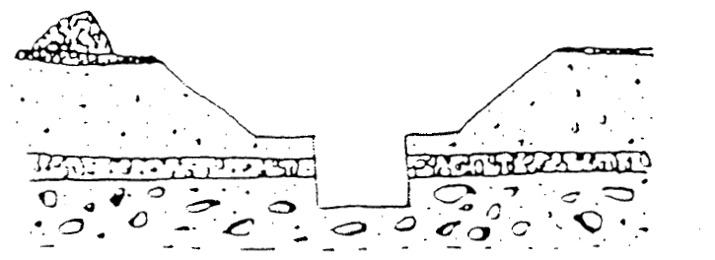

Figure 4: Combination of benching and battering controls

Both benching and battering of excavation walls are methods which minimise the risk of the soil or rock slipping onto the excavation. The design of benching or battering risk controls should be developed by a competent person (for example, geotechnical engineer) relative to the soil type, the moisture content of the soil, the planned height of the excavated face and any surcharge loads acting on the excavated face.
It is not necessary to bench or batter the face of excavations which a competent person (for example, geotechnical engineer) determines are in stable rock or has assessed that there is no risk of collapse. When benching or battering the walls of an excavation, an angle of repose of 45 degrees should not be exceeded unless so designed by a competent person such as a geotechnical engineer and certified in writing.
Benches should be wide enough to stabilise the slopes and to prevent material from the top of the slopes falling down to the working area. They should be sloped to reduce the possibility of water scouring.
During excavation planning, the design of face slopes and widths of benches should also take into consideration the size and type of any earthmoving machinery to be used and any related haul routes.

Shoring
Shoring is a positive ground support system that can be used when the location or depth of an excavation makes battering and/or benching impracticable. It should always be designed for the specific workplace conditions by a competent person, for example, an engineer.
Shoring is the provision of support for excavated face(s) to prevent the movement of soil and therefore ground collapse. It is a common method of ground support in trench excavation where unstable ground conditions, such as in soft ground or ground liable to be wet during excavation such as sand, silt or soft moist clay are often encountered.
Where ground is not self-supporting and benching or battering are not practical or effective risk controls, shoring should be used when there is a risk of the earth, rock or other material forming the side of or adjacent to any excavation work being dislodged or falling and burying, trapping or striking a person in the excavation.
Where such a risk also exists for those installing shoring, other appropriate risk control measures must be in place to ensure the health and safety of persons entering the excavation.

Shoring the face of an excavation should proceed as the work of excavation progresses. Where earthmoving machinery is used, the risk assessment should be used to determine whether any part of the trench may be left unsupported.
The system of work included in the SWMS should ensure workers do not enter any part of the excavation that is not protected and should not work ahead of the shoring protection if it is being progressively installed.
The basic types of shoring are hydraulically operated metal shoring and timber shoring. The most common shoring used consists of hydraulic jacks and steel struts, walls and sheeting. Sometimes aluminium or timber components are used.
The use of metal shoring has largely replaced timber shoring because of its ability to ensure even distribution of pressure along a trench line and it is easily adapted to various depths and trench widths.
Some of the common types of shoring are:
- hydraulic systems
- steel sheet piling
- steel trench sheeting
- timber systems (for example, soldier sets)
- precast concrete panels
- ground anchors, and
- caissons.

Hydraulic systems
Hydraulic support systems are commonly used to provide temporary or mobile ground support while other ground supports are being installed (see Figure 5).
Ground pressures should be considered prior to installation of hydraulic supports. The hydraulic support system should be designed by an appropriately qualified person in consultation with the geotechnical engineer. The hydraulic capacity of the temporary ground support system must be designed to resist the expected ground pressures and potential for collapse.
Hydraulic support systems may become unreliable if not properly maintained and properly used. Frequent inspections of pressure hoses and rams are necessary to detect abrasion, fatigue or damage, such as bent or notched rams.
When a trench has been fully supported, the hydraulic support systems should be dismantled to prevent costly damage. The hydraulic supports should be inspected, repaired if necessary, and carefully stored prior to re-use.
Further information on hydraulic shoring can be found in AS 5047: Hydraulic shoring and trench lining equipment.
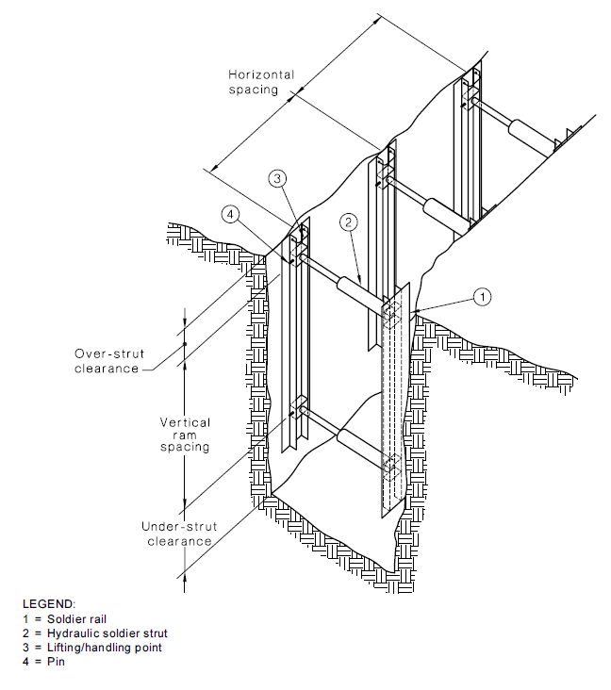

Figure 5: Hydraulic shoring (soldier set style)

Steel sheet piling
Steel sheet piling is generally used on major excavations such as large building foundations or where large embankments are to be held back and can be installed prior to excavation work commencing. It is also used where an excavation is in close proximity to adjoining buildings (see Figure 6).
Sheet piling may be used when ground is so unstable that side wall collapse would be likely during excavation, for example, in loose and running sand. In such cases, sheet piling should be installed before excavation commences.
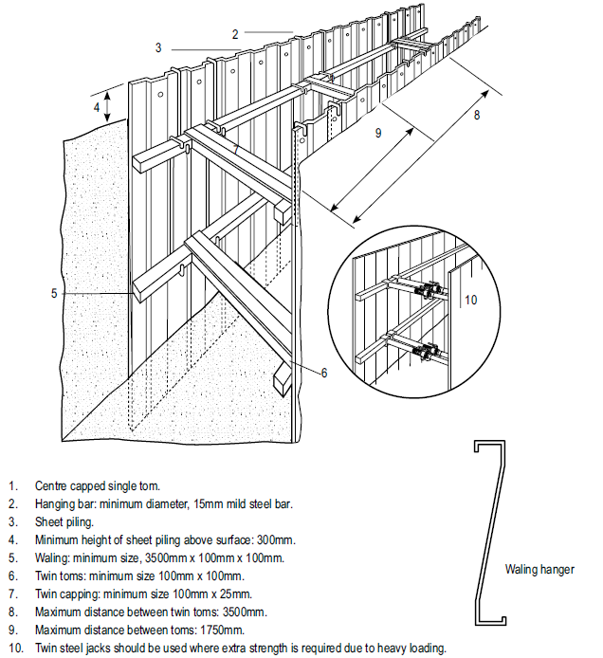
Figure 6: Steel sheet piling [note – delete dimensions]

Steel trench sheeting
Other methods of excavation may require the use of steel trench sheeting or shoring. It is positioned and pneumatically driven in to final depth. Toms and walings are placed into position as the soil is excavated. Timber can be used, but generally, it is found more efficient to use adjustable jacks or struts, as shown in Figure 7.
Steel trench sheeting is lighter in weight than normal sheet piling and in some circumstances may be driven by hand-held pneumatic hammers or electrically operated vibrating hammers. The potential for manual handling injuries to occur in this operation is very high, as is the risk of lacerations due to sharp metal protrusions. These risks should be addressed prior to commencement of driving the steel sheet. Any projections on the underside of the anvil of jack hammers should be removed to prevent damage to the driving cap and potential injury to the operator.
During driving operations, workers may be exposed to noise levels in excess of the exposure standard and a method of controlling the noise exposure will be required.
Steel shoring and trench lining equipment should be designed by a competent person. Further information on steel shoring can be found in AS 4744.1: Steel shoring and trench lining – Design.
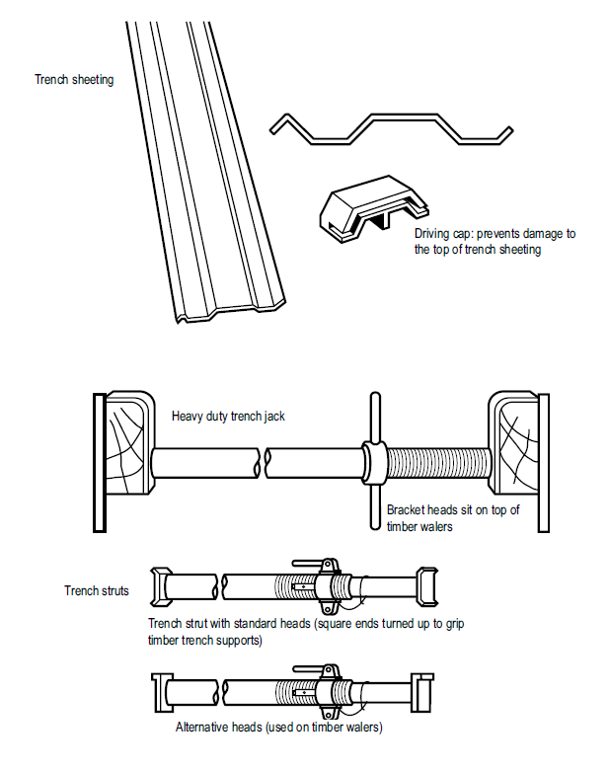

Figure 7: Steel trench sheeting and jacks

Timber soldier sets
The soldier set is a simple form of trench support set which can be formed with steel or timber. This system is mostly used in rock, stiff clays and in other soil types with similar self-supporting properties.

Unlike closed sheeting sets, soldier sets retain the earth where there may be a fault in the embankment. Soldier sets only provide ground support at regular intervals and do not provide positive ground support to the whole excavated face. Open soldier sets are only suitable for use in stable soil types.

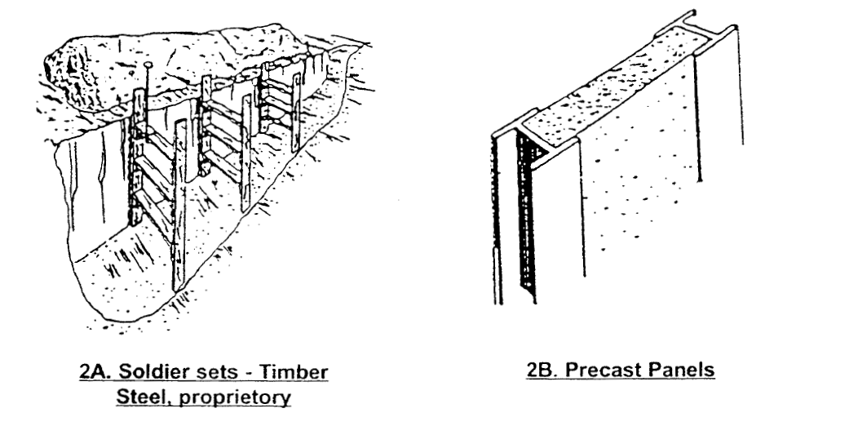
Figure 8: Timber soldier sets

Closed sheeting
Closed sheeting is where vertical timber or metal members are used to fully cover and support a trench wall and which are in turn supported by other members of a ground support system.

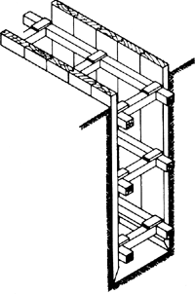

Figure 9: Example of closed sheeting

Side lacing is a form of closed sheeting used primarily to ensure worker safety by preventing soil from slipping by the placement of fill behind timber boards or steel plates (see Figure 10). Side lacing is used in all types of ground, and is particularly useful where long or large diameter pipes are to be installed and in variable ground conditions where steel or timber supports are difficult to install. Side lacing should be firmly wedged into the ground to prevent it from moving when fill is placed against it.
When closed sheeting or side lacing is used to prevent ground collapse, workers should not:
- enter the excavation prior to the installation of the sheeting/lacing
- work inside a trench, outside the protection of sheeting/lacing
- enter the excavation after sheeting/lacing has been removed, or
- enter an area where there is sheeting/lacing, other than by a ladder.

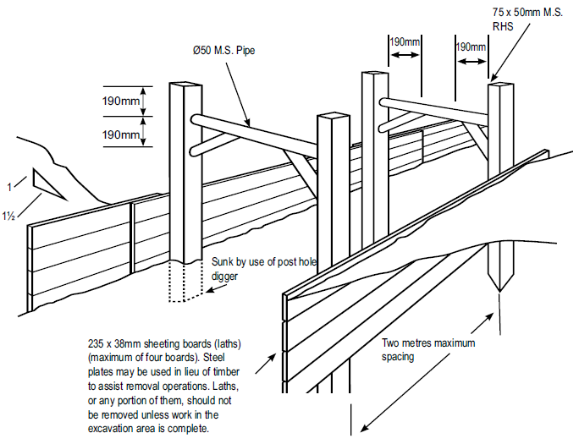

Figure 10: Side lacing in sand trench [note delete dimensions]

Ground anchors
A ground anchor is a tie back to the soil behind the face requiring support and is typically used with steel sheet piling (see Figure 11). Ground anchors may be installed in either granular or clay soils. The design of ground anchors should be carried out by a competent person, for example, a geotechnical engineer.
In granular soil, the anchorage zone is usually a plug of grout located behind the active soil limit line. This plug resists the tension force induced in the stressing cables, due to the shear and cohesion forces developed along its length.
These forces can be due, in part, to the overburden. Removal of soil above installed ground anchors should only be carried out after approval has been received from a competent person, for example, a geotechnical engineer.

Figure 11: Ground anchors – for supporting steel sheet piling

It is possible that removal of the soil between the retaining wall and the active soil limit line may cause the sheet piling to bend. This bending will release the load in the stressing cable, and hence render the ground anchor useless and dangerous to workers within the excavation.

On replacement of the soil, the ground anchor may not develop its original load carrying capacity; also the anchorage of the stressing cable at the face of the sheet piling may be dislodged or loosened - this depends on the type of stressing cable and the respective anchoring systems. While the ground anchoring system is operative, periodic checks with hydraulic jacks and pressure gauges are used to assess anchor behaviour over long periods.

Removal of shoring supports
When removing shoring, the support system should be extracted/dismantled in the reverse order of its installation. Persons performing the work in the excavation should not work outside the protection of the ground support system. No part of a ground support system should be removed until the trench is ready for final backfill and compaction.
Shoring and all support systems should be removed in a manner that protects workers from ground collapse, structural collapse or being struck by structural members. Before removal begins, it may be necessary to install other temporary structural members to ensure worker safety.

Shields and boxes
A shield is a structure, usually manufactured from steel, which is able to withstand the forces imposed by a ground collapse and protect workers within it. Shields can be permanently installed or portable and designed to move along as work progresses.
Many different shield system configurations are available for hire or purchase. Figure 12 shows a typical trench shield.

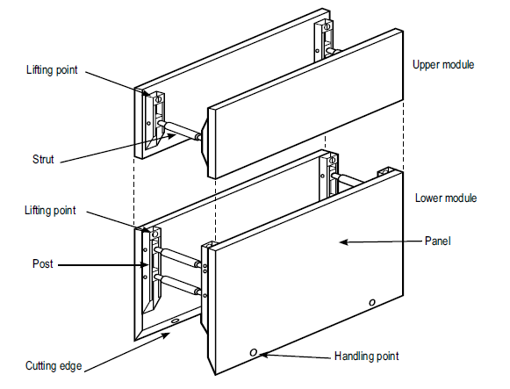

Figure 12: Typical trench shield
Shields and boxes used in trenches are often referred to as trench shields or trench boxes, and are designed and constructed to withstand the earth pressures of particular trench depths and ground types. They incorporate specific lifting points for installation and removal.
Trench shields and boxes differ from shoring in that shoring is designed to prevent collapse where shielding and boxes are only designed to protect workers if a collapse occurs.
Trench shields and boxes are useful where other forms of support are not reasonably practicable to install. They are mainly used in open areas where access is available for an excavator or backhoe to lower and raise the boxes or shields into and out of a trench. They are generally not suitable where access is difficult and ground conditions prevent the use of lifting equipment.
Steel boxes for trench work can be of light or heavy duty construction, depending on the depth of the trench. Trench shields and boxes should be designed by a competent person, for example, an engineer, and can be pre-manufactured to job specific dimensions.
Used correctly, shields and boxes can provide a safe work space for workers who need to enter an excavation. However, trench shields and boxes should be adequately maintained or they may fail unexpectedly, particularly if they have been abused or misused. The manufacturer’s instructions for the installation, use, removal and maintenance of shields and boxes should always be followed.
Trench boxes should not be subjected to loads exceeding those which the system was designed to withstand. Earth pressures are reduced when correct benching and battering practices are used.
Shields and boxes should be stored and transported in accordance with the manufacturer’s instructions. In some situations, heavy duty equipment may require disassembly for transport.
Boxes should be regularly inspected for damage. They should not be altered or modified without the approval of a competent person.

Other ground support methods
Support to the face of an excavation can sometimes be effectively provided by the use of chemical stabilisation techniques which involve injection under pressure of chemical solutions which bind and solidify soil. This method of stabilisation is only possible in porous soils and is expensive. However, under certain circumstances where space limitations are a major consideration and it is not feasible to cut the face of an excavation back to a safe slope, chemical injection may be economical.

Regular inspection
The condition of soil surrounding excavations can change quickly due to the soil drying out, changes in the water table or water saturation of the soil. The soil condition and the state of shoring, battering and trench walls should be frequently checked for signs of earth fretting, slipping, slumping or ground swelling. Where necessary, repair the excavation or strengthen the shoring system from above before allowing work below ground to continue.

Project quality requirements
Each construction project will have quality requirements that must be met. These requirements will detail:
- Dimensions and tolerances of the tasks;
- Material standards;
- Work standards;
- Documentation requirements;
- Project specifications and drawings;
- Client standards.
It is essential that these quality requirements are known, understood and followed in all activities and tasks.

Site Cleanliness

Clearing away loose materials
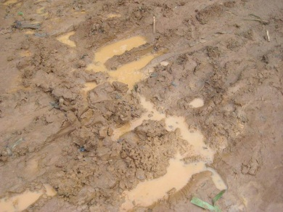
Materials that are located near the edge of the excavation will need to be cleared away to ensure the safety of the people working in or near the excavation.
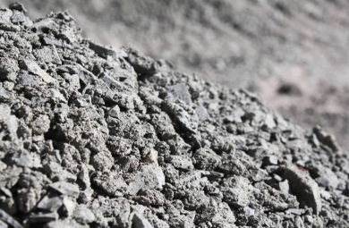
Materials commonly found near excavations could include:
- Clays;
- Silts;
- Stone;
- Gravel;
- Mud;
- Rock;
- Metamorphic – heavy and hard rocks;
- Igneous – volcanic rock could be very hard but could be very light;
- Sedimentary – rocks that could peel or break during excavations;
- Sand;
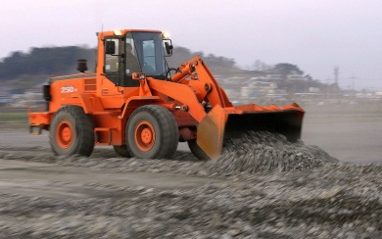
- Topsoil;
- Rubbish or spoil.
By having a basic understanding of soil technology, you will be able to identify the different soils and how the materials will respond in different conditions (such as when the materials are wet). This will then allow you to determine the correct tool for the tasks.
By clearing materials away from the excavation, you are ensuring the materials do not fall into the excavation and cause damage to either people or machines that are working in the bottom of the excavation.
The materials could be cleared by hand or by machine. Knowledge of the type of materials you are moving will allow you to determine the correct movement method.
Once moved, the materials will need to be placed within a designated area ready for reuse or removal, depending upon the needs of the organisation or worksite.

Disposing of materials
After you have finished your work activities, place any waste materials in the bins provided, recycling where possible.
Good housekeeping is necessary to control hazards and risks on the worksite, but also promotes good work practices, pride and ownership of the job. It is your job to clean up after you work activities.
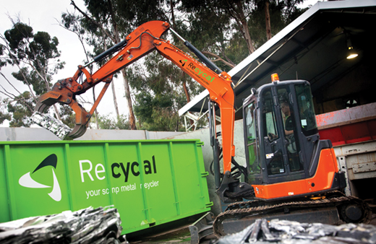

Cleaning, checking, maintaining and Storing tools and equipment
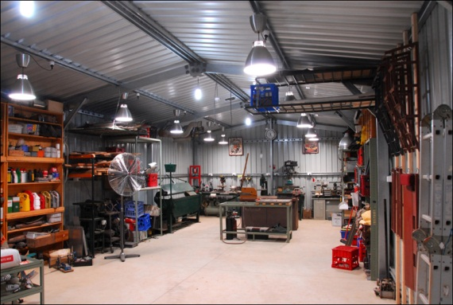
After using tools or equipment, it is important to ensure they are:
- Cleaned;
- Checked for any damage;
- Maintained in line with company or workplace procedures. If anything is wrong report or repair it;
- Stored correctly in the appropriate location.
Maintenance of equipment may include oiling of timber surfaces, greasing of metal surfaces or lubricating moving parts.
Keeping items of equipment in the best possible condition prolongs the working life of the piece of equipment.

Glossary
Barrier | A physical structure which blocks or impedes something.
Barricade | Any object or structure that creates a barrier obstacle to control, block passage or force the flow of traffic in the desired direction
Backfill | Material used for refilling excavations.
Battering | To form the face or side or wall of an excavation to an angle, usually less than the natural angle of repose, to prevent earth slippage.
Bench | A horizontal step cut into the face or side or wall of an excavation to provide horizontal bearing and sliding resistance.
Benching | The horizontal stepping of the face, side, or wall of an excavation.
Caisson | A watertight structure within which construction work is carried on under water
Closed sheeting | A continuous frame with vertical or horizontal sheathing planks placed side by side to form a continuous retaining wall supported by other members of a support system used to hold up the face of an excavation.
Competent person | A person who has acquired through training, qualification or experience the knowledge and skills to carry out the task.  Note: for certain activities, specific additional competencies are required – refer to Chapter 1 of the WHS Regulations.
Earthmoving machinery | Operator controlled mobile plant used to excavate, load, transport, compact or spread earth, overburden, rubble, spoil, aggregate or similar material, but does not include a tractor or industrial lift truck.
Essential services | Services that supply:  (a) gas, water, sewerage, telecommunications, electricity and similar services; or  (b) chemicals, fuel and refrigerant in pipes or lines.
Excavation contractor | The person conducting a business or undertaking that has management or control of the excavation work.
Exclusion zone | An area from which all persons are excluded during excavation work.
Face | An exposed sloping or vertical surface resulting from the excavation of material.
Geotechnical Engineer | An engineer whose qualifications are acceptable for membership of the Institution of Engineers, Australia and who has qualifications and experience in soil stability and mechanics and excavation work.
Hoist | An appliance intended for raising or lowering a load or people, and includes an elevating work platform, a mast climbing work platform, personnel and materials hoist, scaffolding hoist and serial hoist but does not include a lift or building maintenance equipment.
Overburden | The surface soil that must be moved away.
Operator protective device | A roll-over protective structure (ROPS), falling object protective structure (FOPS), operator restraining device and seat belt.
Powered mobile plant | Plant that is provided with some form of self-propulsion that is ordinarily under the direct control of an operator.
Safe slope | The steepest slope at which an excavated face is stable against slips and slides, having regard to the qualities of the material in the face, the height of the face, the load above the face and the moisture conditions for the time being existing.
Shaft | A vertical or inclined way or opening from the surface downwards or from any underground working, the dimensions of which (apart from the perimeter) are less than its depth.
Sheet piling | Vertical, close-spaced, or interlocking planks of steel, reinforced concrete or other structural material driven to form a continuous wall ahead of the excavation and supported either by tie-backs into solid ground structural members from within the excavation as the work proceeds.
Shoring | The use of timber, steel or other structural material to support an excavation in order to prevent collapse so that construction can proceed.
Soldier | Vertical upright steel or timber element used for supporting a trench wall.
Strut | Structural member (usually horizontal) in compression resisting thrust or pressure from the face or faces of an excavation.
Tom | Structural member used to hold soldiers against a trench wall or to press walers apart in a close sheeted trench.
Trench | A horizontal or inclined way or opening:  (a) the length of which is greater than its width and greater than or equal to its depth; and  (b) that commences at and extends below the surface of the ground; and  (c) that is open to the surface along its length.
Trench box | A structure with four vertical side plates permanently braced apart by bracing designed to resist the pressure from the walls of a trench and capable of being moved as a unit.
Trench shield | A steel or metal structure with two vertical side plates permanently braced apart by cross frames or struts designed to resist the pressure from the walls of a trench and capable of being moved as a unit.
Tunnel | An underground passage or opening that:  a) is approximately horizontal; and  b) commences at the surface of the ground or an excavation.
Underground essential services | Essential services that use pipes, cables other associated plant located underground.
Underground essential services information | Information relating to underground essential services that may be affected by the excavation:  (a) the essential services that may be affected  (b) the location, including the depth, of any pipes, cables or other plant associated with the affected essential services, and  (c) any conditions on the proposed excavation work.
Waler | A horizontal steel or timber element used for supporting a trench wall.
Water scouring | An erosion process resulting from the action of the flow of water.
Zone of influence | The volume of soil around the excavation affected by any external load (for example, vehicles, plant, excavated material).

Source: Safe Work Australia, as at http://www.safeworkaustralia.gov.au/sites/swa/about/publications/pages/excavation-work, as on 7th December, 2014.
Source: National VET Content, as at https://nationalvetcontent.edu.au/alfresco/d/d/workspace/SpacesStore/2b298c98-cd25-4461-a844-45e370b00f5e/605/html/resources/depot/seeya/seeya_home.htm, as on 7th December, 2014.

